***East West University***

**Wholesale Management System DB**

**Course Title :** Database Systems

**Course Code :** CSE301

**Section :** 01

**Semester :** Summer 2021

**Submitted To**

**Md Mostofa Kamal Rasel**

Assistant Professor

Department of Computer Science and Engineering

East West University

**Submitted By**

**Group 08**

**Submission Date**

16/09/2021

(**Updated**)

**Group Member**

|  |  |
| --- | --- |
| **Name** | **Id** |
| Adnan Saif | 2018-1-60-157 |
| Ashfaq Ahmed Jadeed | 2018-1-60-158 |
| Md Mahmudur Rahman Limon | 2018-1-60-253 |

**Index**

|  |  |
| --- | --- |
| **Serial No** | **Content** |
| 01 | Project Details |
| 02 | Discussion About Entity Sets |
| 03 | Attributes and Keys |
| 04 | Relationship Sets and Cardinality |
| 05 | ER Diagram |
| 06 | Relational Schema |
| 07 | Database Construction |
| 08 | Updating Table |
| 09 | Delete From Table |
| 10 | Selecting using Natural Join |
| 11 | Profit Calculation |
| 12 | Conclusion |

**Project Details:**

We have created a Database System for Wholesale Management that can carry a lot of data sets so that we can compute faster and efficiently manage the whole system.

In order to do that, we have created several entity sets with couple of attributes for each. Then we have created relations between them. Now we can calculate Profit for any month, we can find the amount which we have and the amount that a customer has to pay. We can also have a easy view to our stock.

**Discussion About Entity Sets:**

Here, we have created 5 Entity sets

1. Customer
2. Product
3. Stock
4. Order_List
5. Payment_Status

**Attributes and Keys:**

For the entity **Customer**, we have created the following attribute-

Customer_Name : Datatype - char(32)

Customer_ID : Datatype - varchar(16), Primary Key

Date_of_Purchase : Datatype - composite

Here component attributes are-

Month : Datatype - char(32)

Date : Datatype - int

Year : Datatype - int

And finally,

Address : Datatype - composite

Here component attributes are-

Road_No : Datatype - varchar(16)

House_No : Datatype - varchar(16)

City : Datatype - char(20)

Area : Datatype - char(32)

For the entity **Product**, we have created the following attribute-

Company_Name : Datatype - char(32)

Company_ID : Datatype - varchar(16)

Product_Name : Datatype - char(32

Price_Per-Unit : Datatype - int

Product_Id : Datatype - varchar(16)

For the entity **Stock**, we have created the following attribute-

Product_Id : Datatype - varchar(16),Primary Key

Product_Name : Datatype - char(32)

Price_Per-Unit : Datatype - int

Quantity : Datatype - int

For the entity **Order_List**, we have created the following attribute-

Product_Id : Datatype - varchar(16),Primary Key

Quantity : Datatype - int

Quantity_Remain : Datatype - int

For the entity **Payment_Status**, we have created the following attribute-

Customer_ID : Datatype - varchar(16)

Status : Datatype - char(20)

**Relationship Sets and Cardinality:**

We have created 4 relationship sets.

ReStock : Entity sets are : Company and Order list.

Cardinality : Many to One

Stock_Order : Entity sets are : Stock and Order_List

Cardinality : Many to Many

Customer_Order : Entity sets are : Customer and Order_List

Cardinality : Many to Many

Payment : Entity sets are : Customer and Payment_Status

Cardinality : One to One

**ER Diagram:**

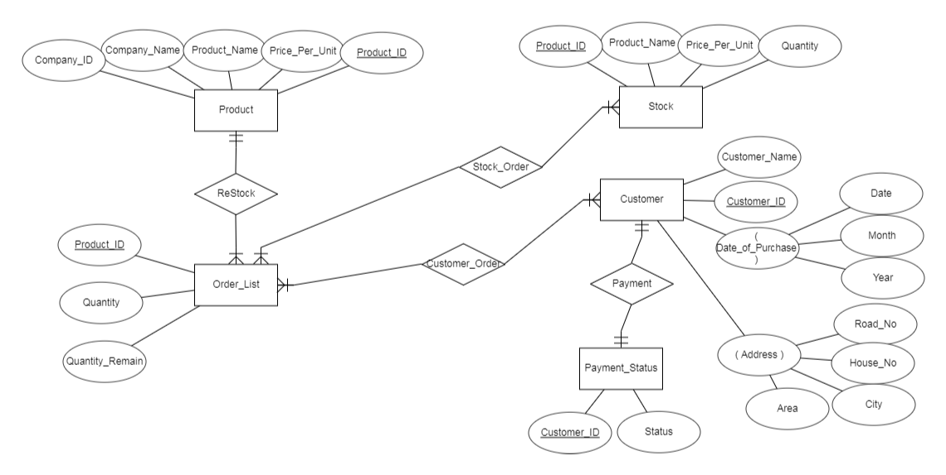

**Relational Schema:**

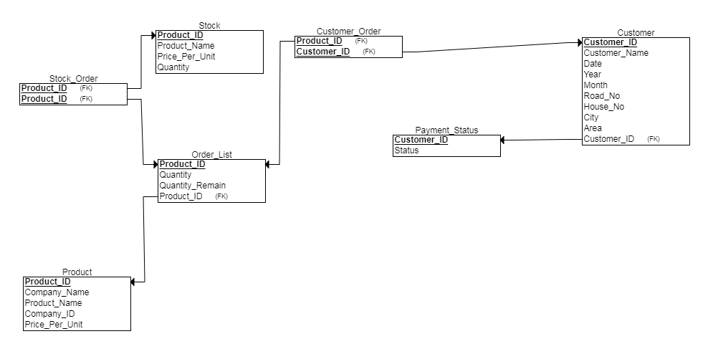

**Database Construction:**

SQL Query:

create table Company(

Company_ID varchar(16) not null,

Company_Name varchar(32) not null,

Product_Name char(32),

Product_ID varchar(16),

Price_Per_Unit int,

PRIMARY key(Product_Name, Product_ID)

);

INSERT into company values('C01','Maggi','Maggi','001',48);

INSERT into company values('C01','Maggi','Naga Maggi','002',90);

INSERT into company values('C01','Maggi','Masala Maggi','003',70);

INSERT into company values('C01','Maggi','Ready-Made Maggi','004',25);

INSERT into company values('C02','Cocola','Noodles','005',60);

INSERT into company values('C02','Cocola','Shemai','006',60);

INSERT into company values('C02','Cocola','Lachcha','007',80);

INSERT into company values('C03','Ifad','Aata','008',45);

INSERT into company values('C04','Pran','Sugar','009',75);

INSERT into company values('C04','Pran','Salt','010',50);

INSERT into company values('C04','Pran','Mango Bar','011',10);

INSERT into company values('C04','Pran','Lichi Drink','012',15);

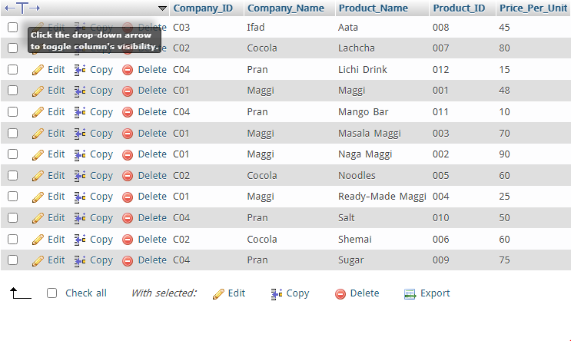

create table Stock(

Product_Name char(32) not null,

Product_ID varchar(16),

Price_Per_Unit int not null,

Quantity int not null,

PRIMARY key(Product_ID)

);

INSERT into stock values('Maggi','001',48,50);

INSERT into stock values('Naga Maggi','002',90,60);

INSERT into stock values('Masala Maggi','003',70,20);

INSERT into stock values('Ready-Made Maggi','004',25,40);

INSERT into stock values('Noodles','005',60,70);

INSERT into stock values('Shemai','006',60,40);

INSERT into stock values('Lachcha','007',80,80);

INSERT into stock values('Aata','008',45,50);

INSERT into stock values('Sugar','009',75,90);

INSERT into stock values('Salt','010',50,50);

INSERT into stock values('Mango Bar','011',10,50);

INSERT into stock values('Lichi Drink','012',15,100);

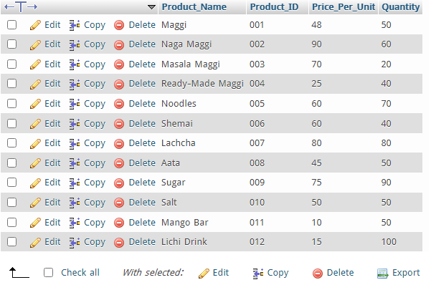

create table Customer(

Customer_Name char(32) not null,

Customer_ID varchar(16) not null,

Purchase_Date int(2) not null,

Purchase_Month char(20) not null,

Purchase_Year int(4) not null,

Road_No varchar(10) not null,

House_No varchar(10) not null,

City char(20) not null,

Area char(20) not null

);

INSERT into customer values('Md Shafiq','CUS001',10,'September',2021,'Rd_No#07','HNo#20','Dhaka', 'Mohammadpur');

INSERT into customer values('Robert D’Cuza', 'CUS002',12,'September',2021,'Rd_No#18','HNo#328','Dhaka', 'Mohammadpur');

INSERT into customer values('Pranto Borua', 'CUS003',24,'January',2021, 'Rd_No#27','HNo#75','Dhaka', 'Mirpur-1');

INSERT into customer values('Jibon Kumar','CUS004',25,'March',2021, 'Rd_No#03','HNo#21','Dhaka', 'Mirpur-6');

INSERT into customer values('Jahidul Hasan','CUS005',06,'July',2021, 'Rd_No#01','HNo#03','Dhaka', 'Badda');

INSERT into customer values('Jabed Ahmed','CUS006',21,'February',2021, 'Rd_No#03','HNo#04','Dhaka', 'Banasree');

INSERT into customer values('Sheuli Begom','CUS007',27,'June',2021, 'Rd_No#06','HNo#21','Dhaka', 'Rampura');

INSERT into customer values('Rokeya Zaman','CUS008',15,'August',2021, 'Rd_No#10','HNo#08','Dhaka', 'Khilgaon');

INSERT into customer values('Md Aslam Khan','CUS009',25,'April',2021, 'Rd_No#04','HNo#15','Dhaka', 'Uttora');

INSERT into customer values('Rohomot Molla','CUS010',18,'May',2021, 'Rd_No#15','HNo#04','Dhaka', 'Basabo');

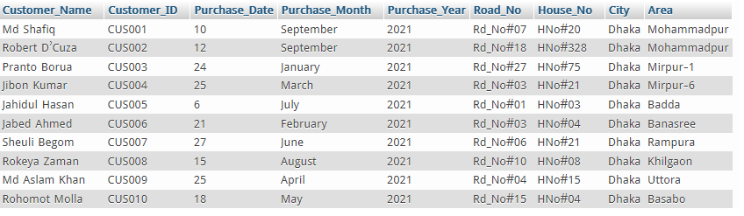

CREATE TABLE order_list(

Customer_ID varchar(16) not null,

Product_ID varchar(16) not null,

Quantity int not null,

Quantity_Remain int not null

);

INSERT into order_list values ('CUS001','001',10,50);

INSERT into order_list values ('CUS002','001',15,50);

INSERT into order_list values ('CUS003','004',20,40);

INSERT into order_list values ('CUS004','012',15,100);

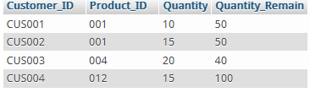

create table Payment_Status(

Customer_ID varchar(16) PRIMARY KEY,

Status char(10),

CONSTRAINT check_status check (Status in('Paid','Due'))

)

INSERT into payment_status VALUES ('CUS003','Paid');

INSERT into payment_status VALUES ('CUS001','Paid');

INSERT into payment_status VALUES ('CUS002','Due');

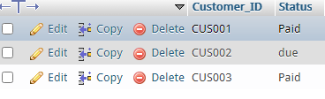

**Updating Table:**

Let’s say we want to update **stock table.**

We will update the quantity of ‘Masala Maggi’ from 20 to 50 and the quantity of ‘Salt’ from 50 to 100.

Here the product Id of ‘Masala Maggi’ is **003** and product Id of ‘Salt’ is **010.**

Now we will select from the table **stock** and change the quantity where product id is 003 and 010 to our desired number.

SQL query:

UPDATE stock set Quantity=50 where Product_ID='003';

UPDATE stock set Quantity=100 where Product_ID='010';

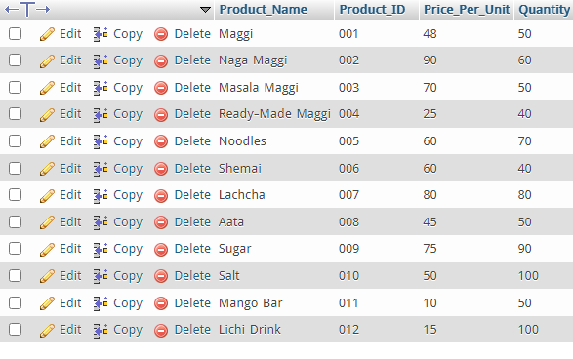

**Delete From Table:**

Let’s say we want to delete a customer’s details from the **customer table.**

For example, we want to delete the profile of ‘Rohomot Molla’ whose customer Id is ‘CUS010’

We will have to find the customer profile from the customer table using the customer_ID and then delete his details.

SQL query:

delete from customer where Customer_ID='CUS010';

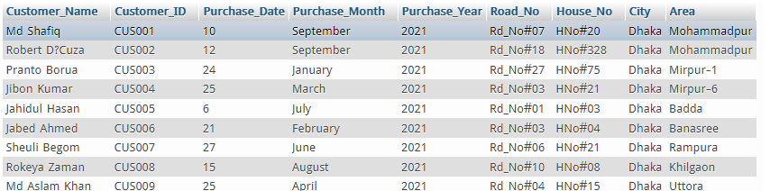

**Selecting using Natural Join:**

If we want to find customer details whose has paid his the payment,

We will use natural join the customer table and the payment_status table and then find whose status = ‘Paid’, and then select the details of those customers.

SQL query:

SELECT Customer_Name, Customer_ID, Purchase_Date, Purchase_Month, Purchase_Year, Road_No, House_No, City, Area from customer NATURAL JOIN payment_status where payment_status.Status = 'Paid';

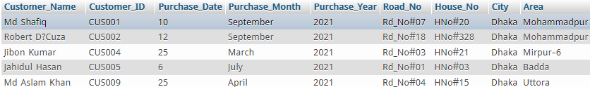

**Profit Calculation:**

For a given month September, calculating profit-

SQL query-

SELECT SUM(order_list.Quantity*stock.Price_Per_Unit) as 'Profit' From stock,order_list NATURAL join customer NATURAL JOIN payment_status WHERE

stock.Product_ID=order_list.Product_ID AND customer.Purchase_Month='September' AND payment_status.Status='Paid';



**Conclusion:**

Due to the pandemic and other issues, the database we’ve created is not that much advanced and there is a lot we can develop. There is a chance that there might be bug problems in the database due to limitation of time. But one thing can be said that, this database can calculate profit and monitor a basic wholesale management system.